Plan M
Definition, Principles and Direction
December 2019
What is Plan M?
Plan M is a new term that is being used as convenient shorthand for some work that is currently being discussed, refined and planned. ‘M’ stands for metadata and the work relates to the need to implement a more efficient bibliographic metadata supply model for UK academic & specialist libraries using the Jisc NBK/Library Hub as core infrastructure.
What Problems will Plan M address?
Presently, many libraries are faced with a situation where a significant proportion of the metadata that they purchase is not fit-for-purpose and they are employing resources in the library to amend the data. In some cases this work will be duplicated across institutions but it is not currently easy to identify where that may be happening. Sharing the amended records is problematic because the purchased data is often only licensed to the institution (rather than purchased outright) and the conditions of the licence often don’t allow libraries to share records with other libraries in a format that is useful for cataloguing purposes.
From the perspective of the data suppliers (most of which are commercial entities), the situation is also unsatisfactory because the cost of creating a record is substantial but the recovery of that cost is necessarily quite complex because of the need to spread the costs as reasonably as possible across the number of institutions that wish to use the record. In other cases, suppliers are obliged to include metadata along with an item of stock they are supplying and have to spend time creating or refining metadata when it is not really their core business.
The problems set out above and many other related issues have been discussed intensively as part of the Jisc-led NBK programme (National Bibliographic knowledgebase).
He problems are also set out in the ‘plan M summary’ slide deck as follows:
Practical | Strategic
Misdirected effort  Having to look in multiple places to find suitable records or creating records where a suitable one already exists | Fragmented Infrastructure  Having multiple delivery mechanisms and different working practices is inefficient and incoherent
Duplicated effort  Different organisations and suppliers making the same or similar changes to a record | Uneconomic practices  Precious resources and investment are being wasted
Unexploited value  The inability to share enhanced records with other organisations who may be able to benefit from them | Sectoral transformation inertia  The focus of cataloguing practice needs to shift towards automation of routine cataloguing and investment in special collections

Who is responsible for Plan M?
Following a series of meetings held with a range of stakeholders, it has been proposed that Jisc takes on responsibility for facilitating and enabling work that will transform the way that bibliographic data is supplied to libraries and how that data can subsequently support research and learning. The work that is required still needs to be fully scoped and worked out but the overall goal and some associated principles have become clear enough for it to be useful to refer to the work as ‘Plan M’. It has no formal or informal connection with ‘Plan S’.
Whilst Jisc will be responsible for taking the work forward, it will be overseen by the governance groups with responsibility for Jisc’s libraries programme and representatives of those groups (including the Executive Directors of RLUK and SCONUL) will have a critical role in validating changes to the economic model between libraries and suppliers.
What are the objectives of Plan M?
The short to medium term aim (as above) is to implement a more efficient bibliographic metadata supply model for UK academic & specialist libraries using the Jisc NBK/Library Hub as core infrastructure. The more detailed objectives are:
Sustainable
- To establish a fair and sustainable ‘pay to share’ bibliographic data ecosystem for UK academic and specialist libraries who are Jisc members and/or NBK contributors. A ‘fair’ model will necessarily involve economically reasonable and sustainable agreements with commercial data creators and suppliers wherever they are adding value to the data marketplace.
Effective
- To design a data supply chain that delivers ‘fit-for-purpose’ records as early as possible in the creation and use cycle. Whilst it may not be realistic to assert that a record can be created at a single point in time that will satisfy all use cases, it should be possible to create utility records that are useful for designated groups of organisations that have common requirements.
Efficient
- To streamline workflows for libraries and suppliers to reduce duplication of effort across the community. By focusing on enhancing a centralised source of data (the NBK), it should be possible to cut down on the number of places that libraries need to source their records from.
Open
- To ensure that all records are available to all Jisc members and/or NBK contributors at the point of need with permissive licensing for sharing and re-use.
Collaborative
- To provide an infrastructure that allows institutions to easily acquire and then re-share enhanced records. By fostering a more collaborative environment, it is anticipated that this will help to promote consortial, regional and national mindsets.
The longer-term goals that the implementation of Plan M is likely to facilitate are set out in the ‘Plan M – Review of Stakeholder Input’ (see ‘10 Year Vision’ section). By creating a data ecosystem that contains current, comprehensive and openly re-useable data, the prospects for using bibliographic data for digital scholarship and working with data scientists increases. By providing a central hub for data and a more coherent and coordinated infrastructure, it becomes easier to see a transition towards a post-MARC data environment for libraries and suppliers.
Working Principles
In the short-term, however, Plan M needs to focus on making achievable and realistic progress
- Focus on need
- Keep it simple
- Choose practical options
What work will Plan M require?
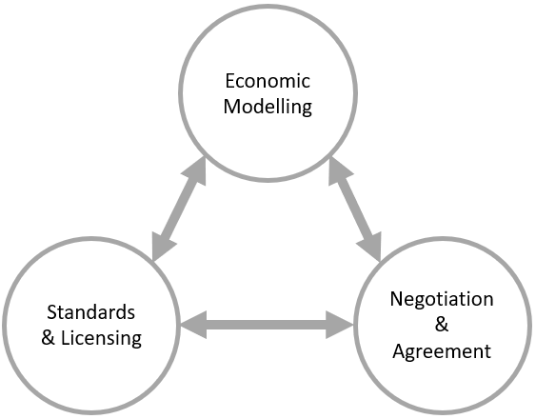
It is envisaged that over the next 18 months, the focus will be on 3 areas of work.
- Economic Modelling
To commission an exploration of the economic basis of the current ecosystem/market place and to work with a range of stakeholders to devise a realistic alternative economic model that will facilitate the Plan M objectives.
The work will require some experience and expertise in cost modelling and benefits evaluation to support negotiations.

- Standards & Licensing
To convene designated stakeholders (Plan M Task & Finish Groups) to explore issues around: quality & standards; and appropriate licensing of data in a new data ecosystem. The groups have already formed and have had preliminary discussions about the work that may be required. It is anticipated that the structure and timescale that will necessarily apply to the commissioned economic modelling work will also benefit this area as there will be dependencies between the activities.
- Negotiation & Agreement
To negotiate and reach agreement with data creators and suppliers to support the new infrastructure and to realise the benefits of a more streamlined and sustainable data marketplace. The other two areas of work will provide inputs into this third area which will be the key enabling action that will allow transition towards a new data ecosystem.
Where will we be in 18 months’ time?
In all three areas, further work is needed to establish what is desirable and what may be possible. The range of stakeholders involved have different incentives and even within the library community, there are different perspectives on what the key problems are and where investment should be directed. However, based on recent discussions, the following outcomes are desirable:
National Agreements
- Agreements will be reached with key data suppliers and infrastructure providers to make metadata available in full and without restrictions to all Jisc member libraries and NBK participants
More Effective Data Supply
- New workflows will be designed to deliver fit-for-purpose records in a timely manner from suppliers who will be accountable through redefined and detailed procurement processes or other agreements
Highly Available Data Discovery, Sharing & Re-use
- The NBK will be the most comprehensive and current aggregation of metadata that it is possible to create and will make that data highly available and openly re-useable through its Library Hub services to all eligible libraries in the UK.
Change of Focus in Library Cataloguing
- The changes in data availability, fitness-for-purpose (including eBook records) and coverage should start to enable libraries to regard the metadata associated with ‘routine acquisition’ as a solved issue, allowing them to focus on more bespoke work and describing special or hidden collections
Use of Data Beyond the Library
- The enhanced re-useability and availability of the data should start to inform work in areas of data science and digital scholarship

Four meetings were held as follows: - May 22nd 2019 – The Future of Metadata – Senate House, University of London - September 27th 2019 – Plan M Task & Finish Groups – Jisc, London - September 30th 2019 – Towards More Efficient Bibliographic Metadata, Focus Group 1 – Jisc, London - October 21st 2019 – Changing the Library Data Ecosystem, Focus Group 2 – Jisc, Manchester
Well over 100 attendees across the 4 meetings (some duplicate) representing university libraries, national libraries, commercial and not-for-profit data suppliers, library stock suppliers, standards bodies, industry membership organisations, procurement consortia, aggregators

